



Mercury API Specification Processor –
List All Banks Request
Inbound From Client

Table of Contents
Confidentiality Notice: This document contains private information about Merccury (Pty) Ltd. You can't copy, reproduce, or share its product details, intellectual property, or design methods with anyone else unless you have our written consent.

1) Document Purpose 3
2) Process Flow 4
3) List All Banks Request Message from Client 5
4) Embedded Participant Message Structures 16

Document Purpose
The purpose of this document is to provide a detailed specification of the List All Banks Request call to be received by the Mercury Processor API from the Client (Mercury Client) as part of the List All Banks Process.

This document will focus on the Inbound Message from the Mercury Client to the Mercury Processor API and will indicate the processing to be completed before responding to the List All Banks message to be sent to the Mercury Client.

Process Flow
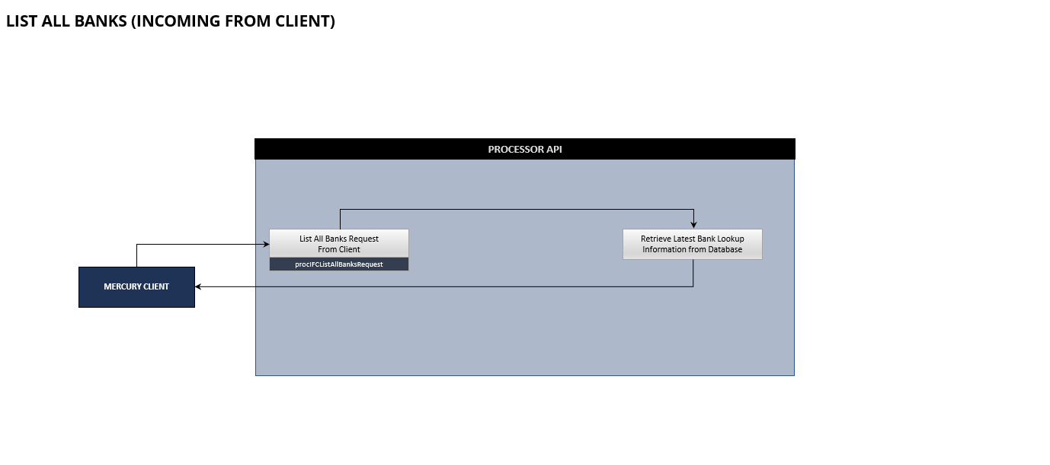
The List All Banks process flow indicated above is initiated on the Mercury client and the request will be processed from the Mercury Client to the Mercury Processor API. After decryption and validation of the message by the Mercury Processor API the List All Banks Request will be processed the Mercury Processor API will respond to the Mercury Client. This will be a synchronous message.

List All Banks Request Message from Client

Overview
This List All Banks Request API is invoked during the processing of the List All Banks Request received from the Mercury Client.

Process Flow
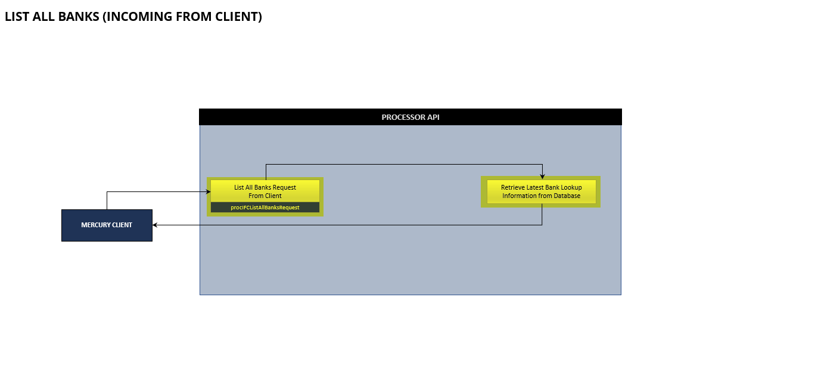When receiving the List All Banks Request message from the Mercury Client for processing, the Mercury Processor API need validate, accept and respond to the Mercury Client with the list of all the Banks on the Mercury System along with the associated data.

As part of the basic API Processing the following steps need to be followed:
STEP | DESCRIPTION
1. | Store and Log the Message Request Details in the Message Request Detail table for auditing purposes.  Table Name: mrd_Message_Request_Detail
2. | Initialize the List All Banks Request (In From Client) Message Class with the details received in the API Call from the Mercury Client.  Message Class: procIFCListAllBanksRequest
3. | Validate the Secure Token contained in the Message against the content of the List All Banks Request Message received from the Mercury Client.  Error Response Code: ECL8060006
4. | Complete the following basic validations on the Message Class  - Field Types  Validate if the values received in the message are of the correct type as specified by the Message Class Structure.  Error Response Code: ECL8060001  - Field Lengths  Validate if the values received conform to the field lengths specified by the Message Class Structure.  Error Response Code: ECL8060002  - Required Fields  Validate if all the required fields have been received as specified by the Message Class Structure.  Error Response Code: ECL8060004  - Duplicates  Validate that the message received is not a duplicate. Base validation on the following fields:  - Transaction Identifier  - Message Request Type  - Direction  - Subscriber ID  - HTTP Response Code (200 cannot already exist)  Error Response Code: ECL8060021
5. | Complete the following custom validations on the Message Class  - Subscriber ID  Validate if the Subscriber ID exist on the Client API Configuration Table.  Table Name: cac_Client_API_Configuration  Error Response Code: ECL8050022
6. | If any of the validations have failed, respond to the Mercury Client with the appropriate Error Response Code and description of the error detected.  Use the List All Banks Response structure.  The details of the response to the Mercury Client should also be logged against the Entry that was added to the Message Request Detail table.
7. | If all the validations have passed, continue with the retrieval of the Bank Details (from the Bank Details Lookup Table) and the construction of the Response to the List All Banks Request.  NOTE: Construct the appropriate Message Identifier value to be added to the Message Request Detail table (for reference) Example: 20231010_SASF_BKLST_910000000000001
8. | The details of the response to the Mercury Client should also be logged against the Entry that was added to the Message Request Detail table.

Message Requirements
DEVELOPMENT
ENDPOINT | https://payments-test.azurefd.net/api/beapiGlobalMercuryClientProcessor
HEADERS | x-beapiglobalmercuryclientprocessor-api-version  1.0.0-dev  Ocp-Apim-Subscription-Key  TBC  environment  LIVE  subscriberID  TBC

STAGING
ENDPOINT | https://payments-test.azurefd.net/api/beapiGlobalMercuryClientProcessor
HEADERS | x-beapiglobalmercuryclientprocessor-api-version  1.0.0-staging  Ocp-Apim-Subscription-Key  TBC  environment  LIVE  subscriberID  TBC

PRODUCTION
ENDPOINT | https://dt-apim-zan-prod-paymenthub.directtransact.co.za/api/beapiGlobalMercuryClientProcessor
HEADERS | x-beapiglobalmercuryclientprocessor-api-version  1.0.0  Ocp-Apim-Subscription-Key  TBC  environment  LIVE  subscriberID  TBC

Request
REQUEST DETAIL
ENDPOINT | {Processor Endpoint}/procIFCListAllBanksRequest
METHOD | POST

REQUEST BODY
CLASS NAME | clsIFCListAllBanksRequest
FIELD | DESCRIPTION
secureToken | Required  Unique encrypted value constructed from the field values contained in the message  Format:  String
subscriberID | Required  Unique Subscriber ID that is issued by the Payment Hub to uniquely identify the source from where the call is received.  Format:  String  Example:  902
creationDateTime | Required  Creation Date Time of the request from the Payer Participant API.  Format: String  yyyy-MM-ddThh:mm:ss:SSSSSS  Example:  2021-11-17T11:27:53.015708
transactionIdentifier | Required  Unique Identification value assigned by the Mercury Client, to unambiguously identify the request on the Mercury Client System. This identification is used to link the request received from the Mercury Client to the Request that is to be processed by the Mercury Client Processor. This value will also be used to ensure the request is unique and will be used for duplicate validation.  Format:  String  Example:  54000000000000001

Response
API responses will return HTTP status code in the 2xx range. The response body will contain the response of the API as described in this specification.

NOTE: The List All Banks Response will be received for all HTTP Status Codes, but for a Results Code that does not indicates success, the BankDetails Array will be empty and thus not included in the response.
RESPONSE
CLASS NAME | clsOTCListAllBanksResponse
FIELD | DESCRIPTION
messageIdentification | Required  Unique Message Identification for the Message Request for which this response structure is created.  Format:  String: alphabetic, numeric, and underscores (_), e.g. spaces are not allowed; max length 35 characters.  YYYYMMDD_XXXX_TTTTT_SSS999999999999  YYYYMMDD - Date the message is created  XXXX – First 4 characters of the senders BICCode  TTTTT – Service Code  SSS – Unique Subscriber ID  999999999999 – 12-digit sequence number (for the current day – reset after day)  Example:  20231010_SASF_BKLST_910000000000001
messageResultDetail | Required  A Message Result structure.
bankDetails | Conditional  Note that this only be populated if the resultCode in the Message Result structure indicates a success (ECL8060000).  An array of Bank Detail structures.

Response Codes
Internal Response Codes available for the Message Request Response are listed below. The Response Codes will have a format of ECLABBCCCC and is compiled as follows:

ECL Fixed value for the Response Code Prefix
A Service Indicator where 8 will indicate the Processor API as the origin of the response.
BB Message Type Indicator (2 digits) where 06 will indicate the List All Banks Request Message Type.
CCCC Unique value per Response indicating a unique Response.

RESPONSE CODES
HTTP STATUS | RESPONSE CODE | RESPONSE DESCRIPTION
200 | ECL8060000 | SUCCESS
200 | ECL8060001 | ERROR_INVALID_FIELD_TYPE
200 | ECL8060002 | ERROR_INVALID_FIELD_LENGTH
200 | ECL8060003 | ERROR_INVALID_FIELD_VALUE
200 | ECL8060004 | ERROR_REQUIRED_DATA_MISSING
200 | ECL8060005 | ERROR_INTERNAL_SYSTEM_ERROR
200 | ECL8060006 | ERROR_CRYPTOGRAPHY
200 | ECL8060007 | ERROR_INVALID_SOURCE_PARTICIPANT
200 | ECL8060021 | ERROR_DUPLICATE_TRANSACTION
200 | ECL8060022 | ERROR_INVALID_SUBSCRIBER_ID

Sample Request
{
"secureToken": "string",
"subscriberID": "string",
"creationDateTime": "string",
"transactionIdentifier": "string"
}

Sample Request Message
{
"secureToken": "07ac3cf0add872d8af56e2ac62213b9add6a4fb61977e1fe109c54dda67c1c48",
"subscriberID": "910",
"creationDateTime": "2023-10-03T11:27:53.015708",
"transactionIdentifier": "1A66C164-0EDA-4170-8D13-FBF9E495B680"
}

Sample Response
{
"messageRequestID": "string",
"messageResultDetail": {
"resultCode": "string",
"resultDescription": "string",
"resultMessage": "string",
"transactionIdentifier": "string",
"processingTransactionId": "string"
},
"bankDetails": [
{
"bankId": "string",
"bankName": "string",
"bankDefaultBranch": "string",
"bankBICFI": "string",
"bankActive": true
},

{
"bankId": "string",
"bankName": "string",
"bankDefaultBranch": "string",
"bankBICFI": "string",
"bankActive": true
},
{
"bankId": "string",
"bankName": "string",
"bankDefaultBranch": "string",
"bankBICFI": "string",
"bankActive": true
}
]
}

Sample Request Message Success
{
"messageRequestID": "20231010_SASF_BKLST_910000000000001",
"messageResultDetail": {
"resultCode": "ECL8060000",
"resultDescription": "SUCCESS",
"resultMessage": "",
"transactionIdentifier": "1A66C164-0EDA-4170-8D13-FBF9E495B680",
"processingTransactionId": "CAE4F68F-BFB1-4FB2-B2B0-4AA94096142E"
},
"bankDetails": [
{
"bankId": "39",
"bankName": "STANDARD BANK SOUTH AFRICA",
"bankDefaultBranch": "51001",
"bankBICFI": "SBZAZAJ0",
"bankActive": true
},

{
"bankId": "69",
"bankName": "BIDVEST BANK",
"bankDefaultBranch": "462005",
"bankBICFI": "BIDBZAJ0",
"bankActive": true
},
{
"bankId": "48",
"bankName": "CAPITEC BANK CPC",
"bankDefaultBranch": "470010",
"bankBICFI": "CABLZAJ0",
"bankActive": true
}
]
}

Sample Request Message Error
{
"messageRequestID": "20231010_SASF_BKLST_910000000000001",
"messageResultDetail": {
"resultCode": "ECL8060006",
"resultDescription": "ERROR_CRYPTOGRAPHY",
"resultMessage": "Invalid Secure Token",
"transactionIdentifier": "1A66C164-0EDA-4170-8D13-FBF9E495B680",
"processingTransactionId": "CAE4F68F-BFB1-4FB2-B2B0-4AA94096142E"
}
}

Embedded Participant Message Structures

Bank Detail
Note: This structure is only used for the List All Banks Message.
MESSAGE RESULT
CLASS NAME | clsProcBankDetail
FIELD | DESCRIPTION
bankId | Required  Unique Id assigned to the Bank by the source.  Format:  String  Example:  42
bankName | Required  The Bank Name (to be used to display in the list when the Account details for the Transaction is captured.  Format:  String; max length 100 characters.  Example:  ABSA Bank
bankDefaultBranch | Optional  Populated if the Bank has a default Branch Code  Format:  String; max length 6 characters.  Example:  632005
bankBICFI | Required  The BICFI Code Associated with the Bank.  Format:  [A-Z0-9]{4,4}[A-Z]{2,2}[A-Z0-9]{2,2}([A-Z0-9]{3,3}){0,1}  Example:  ABSAZAJJ
bankActive | Required  A True/False value indicating the Bank Status  Format:  true/false  Example:  true

Message Result
Note: This structure is used in various Message Request Structures in the Processor API to and from the Client and Host.
MESSAGE RESULT
CLASS NAME | clsMessageResult
FIELD | DESCRIPTION
resultCode | Required  Appropriate Response Code for the Message Type  Format: String; length 10 characters.
resultDescription | Required  Appropriate Response Description for the Message Type  Format: String; max length 50 characters.
resultMessage | Optional  Additional Response Detail associated with the Response Code and Description (Example: Field Name that failed the validation)  Format: String; max length 256 characters.
transactionIdentifier | Required  This will be the Transaction Identifier received from the Mercury Client for the List All Banks Request received by Mercury.
processingTransactionId | Conditional  Based on whether the List All Banks Request was accepted by the Mercury System that received the request, return the Mercury Transaction Id that was assigned for the request.

